Newsletter 03 July 2020 Term 2 Week 10

Principal’s Report

At last the mid-year break is here after what feels like the longest school term in memory. I hope all members of our school community can take some time to relax and spend some socially distanced time with friends and family. I include Year 12 students in this too, as they also need to take some time for themselves and balance this with their study schedules.

Thank you to all parents and carers who responded to the online survey – we had over 400 responses which will assist us in our reflections on student learning and engagement during the period they were learning from home. Your engagement in the survey, and your support of the online learning is most appreciated. We have also gathered feedback from students and teachers and will use this data at our School Development Day on Monday, 20 July, to inform our planning for improving our practice.

Parent/Carer–Teacher interviews for Years 8-11 are coming up early in Term 3. All parents and carers of girls in these Year groups have been emailed with information about how to register for a Zoom meeting with your daughter’s teachers. Feedback from Year 7 and Year 12 parents and carers, and from teachers, has been very positive regarding this online meeting experience, so we expect the next rounds of interviews will run equally smoothly. Year 8, 9 and 10 Student Progress reports will be available for parents and carers early next term:
Year 10 - Week 3
Year 9 - Week 4
Year 8 - Week 5

These reports are later than usual because of the major disruptions to our usual schedules. I thank all families for your patience.

Year 10 taster week and subject selection:
Year 10 students have enjoyed three days of learning about senior school and the new subjects they will be able to choose for Year 11. Teachers have given presentations on the broad range of subjects on offer and groups of Year 12 students answered questions ranging from; ‘How do you organize your study and social life?’ to ‘What are some of your favorite topics in Legal Studies?”. Students have also learnt about the role of school-based assessment in contributing to the final HSC mark. They have received advice on how to make the right choices for their next phase of school learning. The advice is always the same - from teachers, Year 12 students and senior executive: choose subjects that you will enjoy and are good at, because if you choose these subjects you will be more motivated to stay focused on your study and will achieve better results.

I hope parents and carers can spend some time with your daughters to view the materials that are available to students through their online classrooms. Students will make their selections early next term.

I hope everyone has a relaxing and rejuvenating mid-year holiday. Stay safe (and stay safely distanced).

Elizabeth Diprose
Principal

WGHS P&C

Next P&C Meeting will be held via ZOOM on Tuesday 18 August at 7pm

- Please follow our Facebook page to stay informed of interesting things happening in the parent community. You don’t have to be a Facebook member to access the page.
- All parents are welcome at P&C meetings. These will be via Zoom until further notice. Please download Zoom before joining the meeting
- Any queries or matters to be raised can be raised via the Secretary at the email address below at any time.

- Facebook: Facebook.com/wghspandc
- Email: secretary@wghspandc.org.au

Details TBC

JULY 2020 CALENDAR

Week 1A
Monday 20 – Friday 24 July
Monday 20 July – Staff Development Day
Tuesday 21 July – All students return to school
Thursday 23 July – School Photo – catch up day

Week 2B
Monday 27 June – Friday 31 July

Term 3 Dates: 21 July – 25 September 2020

Parent Teacher Interviews
The following Parent Teacher Nights will be held in Term 3:
Years 10 & 11
Week 3 – 05 August, 2020
Years 9 & 10
Week 4 – 12 August, 2020

Year 10 Subject Selection Week

Year 10 students attended Willoughby Girls High School subject selection activities this week and listened to many presentations from teachers and speakers from Year 12. A big thank you to all as the students were able to gain valuable insights into becoming a senior student at Willoughby Girls and pathways beyond school.

Ms Morris
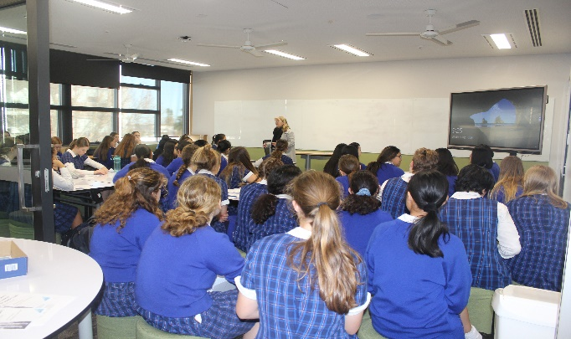
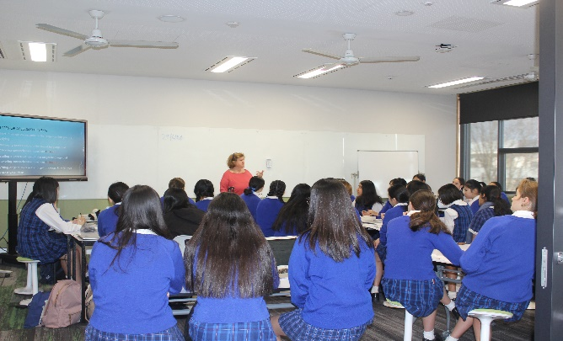
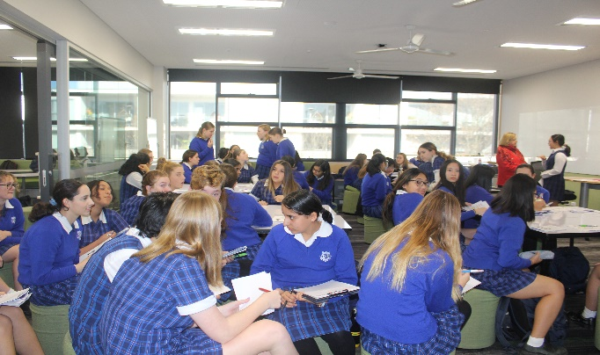
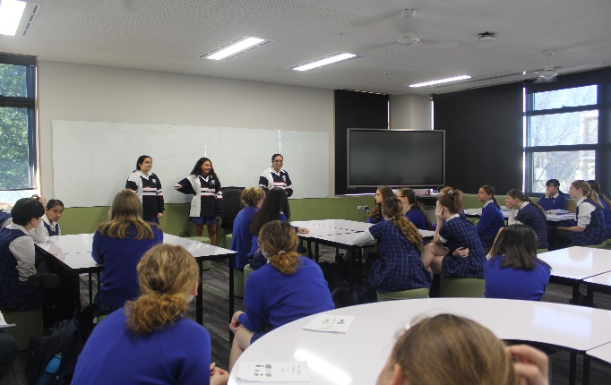
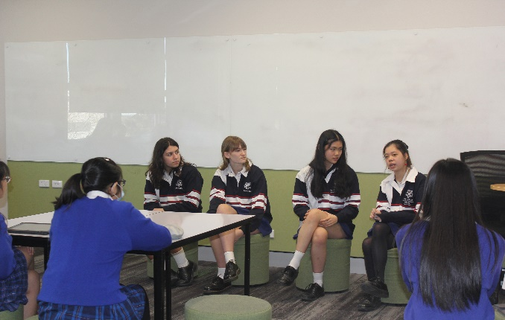
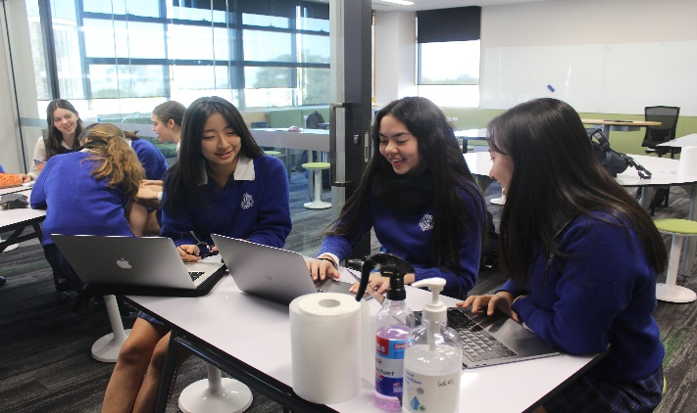
Careers

COMMUNITY NOTICE BOARD

City of Ryde and Lane Cove Council are bringing Dr Michael Carr-Gregg to your screens to provide 2 x FREE workshops to help parents during and post COVID-19.
https://www.eventbrite.ca/e/raising-resilient-kids-in-the-coronavirus-era-w-dr-michael-carr-gregg-tickets-106864933894
Raising Resilient Kids in the Coronavirus Era
The spread of the Coronavirus has turned life upside down, almost overnight, for millions of people around the world. Being a young person is complicated even without a global pandemic in the mix, and many adults are struggling to navigate the new reality of remote schoolwork, lots of family time, and a ton of uncertainty about what happens next. This webinar offers practical, evidence-based strategies on what to say and what to do in these challenging times. It also includes information on managing remote learning and self-care.
Suitable for: Parents, grandparents and adult carers of younger children.
https://www.eventbrite.ca/e/parenting-teenagers-post-coronavirus-lockdown-w-dr-michael-carr-gregg-tickets-106870733240
Parenting Teenagers Post Coronavirus Lockdown
In just a matter of weeks, the coronavirus pandemic has turned our vibrant modern cities into virtual ghost towns. Thousands of Australians are without jobs and 24.6 million people were told to stay home unless they absolutely have to go outside. Hard enough as an adult, but particularly tricky if you are a teenager trying to tackle the tasks of adolescent development. This webinar explains the impact of the coronavirus lockdown on teenagers. Focusing on their mental health, it gives participants some skills to manage teenagers especially as they transition back to school in all year levels, deal with disappointment and try to regain their motivation.
Suitable for: Parents, grandparents and adult carers of teenagers.

COMMUNITY NOTICE BOARD

